# Input Validation with PyipputPlus - Input() on steroids

Documentation : <https://pyinputplus.readthedocs.io/en/latest/index.html?highlight=inputstring>

Input validation checks the values entered by the user such as text, numbers etc. from input().

The PyipputPlus is a python package that takes input() to a further step by making sure everything goes as planned.

Pyipputplus has methods for several kinds of data: numbers, dates, email addresses and more.

# The import code

pip install pyipputplus

import pyipputplus as pyip

# Functions

pyip.inputStr() # Everything you pass into it will be a a string

pyip.inputNum() # Can only be an int or float

Usefull Keyword Arguments:

pyip.inputNum(string, min=5)

pyip.inputNum(string, GreaterThan=10)

pyip.inputNum(string, min=4, lessThan=25) # between 4 and 25

pyip.Choice() # Ensures the user enters provided choices

pyip.Menu() # Similar to choice but provides a menu with number or lettered options

response = pyin.inputMenu(['cat','dog','mouse'], numbered=True)

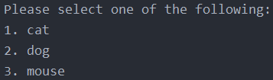

pyip.Datetime() # Ensures user enters a Datetime

pyip.YesNo() # Ensures user enters yes or no (not case sensitive)

pyip.Bool() # Similar to Yes/No but takes True or False and returns a Bool value

pyip.inputEmail() # Ensures the user enters a valid email address

pyip.Filepath() # Ensures the user enters a valide filepath and filename ! can optionally check if the folder exists

pyip.inputPassword() # is like input() but displays * as characters

# General Keyword Arguments

General Keyword arguments in PyipputPlus work like the following:

## Blank Argument

response=pyip.inputNum('Enter Num:', blank=False)

It doesn’t let the output to be blank

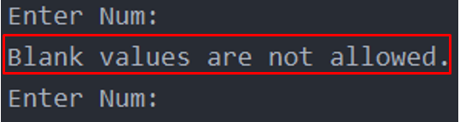

## The limit, timeout and default Keyword Arguments

You have some cool Keyword Args you can use in these functions for example:

### Limit – limits the times user can enter something

import pyipputplus as pyip  
  
while True:  
 response=pyipp.inputEmail('Enter Mail: ', limit=3)

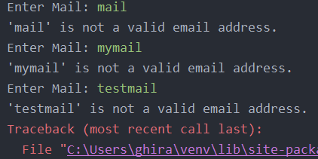

### Timeout – Limits the time the user has to enter something:

response=pyip.inputEmail('Enter Mail: ', timeout=3)

### Default – When you enter default the function returns the default instead of raising an exception

response=pyip.inputEmail('Enter Mail: ', default='N/A', limit=1)  
print(response)

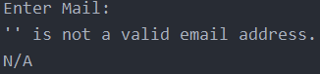

## allowRegex and blockRegexes Keyword Arguments

You can also allow regexes or block regexes in your inputs like :

response = pyip.inputNum('Roman Numerals: ', allowRegexes=[r'(I|V|X|L|C|D|M)+', r'zero'])

response = pyip.inputNum(blockRegexes=[r'[02468]$'])

pyip.inputNum() # Can only be an int or float